CLOUD DATA ENG BATCH 5 SQL TEST

USE[NEXT_COLA_OLTP]

--Q1. List top 5 customers by total order amount.
--Retrieve the top 5 customers who have spent the most across all sales orders. Show CustomerID, CustomerName, and TotalSpent.
SELECT TOP 5
c.CustomerID,c.Name AS CustomerName ,SUM(so.TotalAmount) AS TotalSpent
FROM dbo.Customer c
JOIN dbo.SalesOrder so ON c.CustomerID = so.CustomerID
GROUP BY c.CustomerID,c.Name;

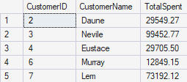

--Q2. Find the number of products supplied by each supplier.
--Display SupplierID, SupplierName, and ProductCount. Only include suppliers that have more than 10 products.

SELECT s.SupplierID,s.Name AS SupplierName,COUNT(pod.ProductID) AS ProductCount
FROM dbo.Supplier s
INNER JOIN dbo.PurchaseOrder po ON po.SupplierID=s.SupplierID
INNER JOIN dbo.PurchaseOrderDetail pod ON po.OrderID=pod.OrderID
GROUP BY s.SupplierID,s.Name
HAVING COUNT(pod.ProductID) > 10;

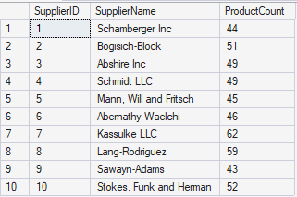

--Q3. Identify products that have been ordered but never returned.
--Show ProductID, ProductName, and total order quantity.

SELECT p.ProductID,p.Name AS ProductName,SUM(sod.Quantity) AS total_order_quantity
FROM dbo.Product p
INNER JOIN dbo.SalesOrderDetail sod ON p.ProductID = sod.ProductID
WHERE p.ProductID NOT IN (
SELECT DISTINCT rd.ProductID
FROM dbo.ReturnDetail rd )
GROUP BY p.ProductID,p.Name;

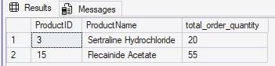

--Q4. For each category, find the most expensive product.
--Display CategoryID, CategoryName, ProductName, and Price. Use a subquery to get the max price per category.

SELECT ca.CategoryID,ca.Name AS CategoryName,p.Name AS ProductName,p.Price
FROM dbo.Category ca
INNER JOIN dbo.Product p ON ca.CategoryID=p.CategoryID
WHERE p.Price = (
SELECT MAX(p2.Price)
FROM dbo.Product p2
WHERE p2.CategoryID = ca.CategoryID)
ORDER BY ca.CategoryID;
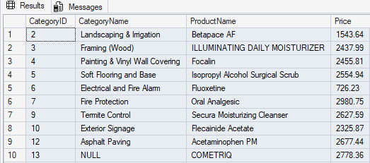

--Q5. List all sales orders with customer name, product name, category, and supplier.
--For each sales order, display:
--OrderID, CustomerName, ProductName, CategoryName, SupplierName, and Quantity.

SELECT so.OrderID,c.Name AS CustomerName,p.Name AS ProductName,
cat.Name AS CategoryName,s.Name AS SupplierName,sod.Quantity
FROM dbo.SalesOrder so
JOIN dbo.Customer c ON so.CustomerID=c.CustomerID
JOIN dbo.SalesOrderDetail sod ON so.OrderID=sod.OrderID
JOIN dbo.Product p ON sod.ProductID=p.ProductID
JOIN dbo.Category cat ON p.CategoryID=cat.CategoryID
JOIN dbo.PurchaseOrderDetail pod ON p.ProductID=pod.ProductID
JOIN dbo.PurchaseOrder po ON pod.OrderID=po.OrderID
JOIN dbo.Supplier s ON po.SupplierID=s.SupplierID
ORDER BY so.OrderID ASC;

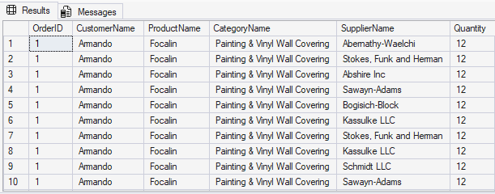

--Q6. Find all shipments with details of warehouse, manager, and products shipped.
--Display:
--ShipmentID, WarehouseName, ManagerName, ProductName, QuantityShipped, and TrackingNumber.

SELECT sh.ShipmentID,l.Name AS WarehouseName,e.Name AS ManagerName,
p.Name AS ProductName,sd.Quantity AS QuantityShipped,sh.TrackingNumber
FROM dbo.Shipment sh
JOIN dbo.Warehouse w ON sh.WarehouseID=w.WarehouseID
JOIN dbo.Location l ON w.LocationID=l.LocationID
JOIN dbo.Employee e ON w.ManagerID=e.EmployeeID
JOIN dbo.ShipmentDetail sd ON sh.ShipmentID=sd.ShipmentID
JOIN dbo.Product p ON sd.ProductID=p.ProductID
ORDER BY sh.ShipmentID;

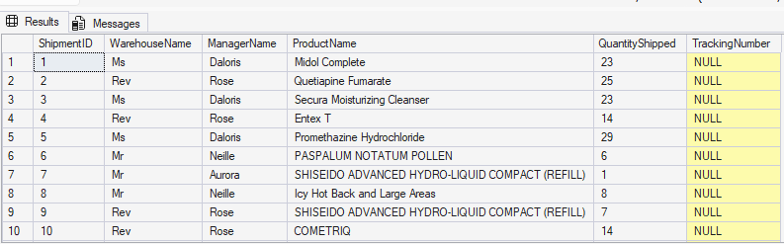

--Q7. Find the top 3 highest-value orders per customer using RANK(). Display CustomerID, CustomerName, OrderID, and TotalAmount.
WITH RankedOrders AS (
SELECT c.CustomerID,c.Name AS CustomerName,so.OrderID,so.TotalAmount,
RANK() OVER(PARTITION BY c.CustomerID ORDER BY so.TotalAmount DESC) AS rk
FROM dbo.Customer c
JOIN dbo.SalesOrder so ON c.CustomerID=so.CustomerID
)
SELECT CustomerID,CustomerName,OrderID,TotalAmount
FROM RankedOrders
WHERE rk<=3
ORDER BY CustomerID,rk;

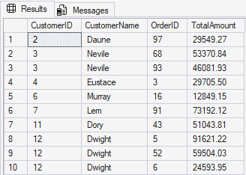
--Q8. For each product, show its sales history with the previous and next sales quantities (based on order date). Display ProductID, ProductName, OrderID, OrderDate, Quantity, PrevQuantity, and NextQuantity.
WITH SalesHistory AS(
SELECT p.ProductID,p.Name AS ProductName,so.OrderID,so.OrderDate,sod.Quantity
FROM dbo.Product p
JOIN dbo.SalesOrderDetail sod ON p.ProductID=sod.ProductID
JOIN dbo.SalesOrder so ON sod.OrderID=so.OrderID
)
SELECT ProductID,ProductName,OrderID,OrderDate,Quantity,
LAG(Quantity) OVER(PARTITION BY ProductID ORDER BY OrderDate) AS PrevQuantity,
LEAD(Quantity) OVER(PARTITION BY ProductID ORDER BY OrderDate) AS NextQuantity
FROM SalesHistory
ORDER BY ProductID,OrderDate;

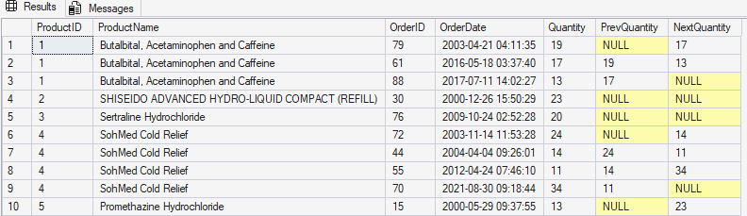

--Q9. Create a view named vw_CustomerOrderSummary that shows for each customer:
--CustomerID, CustomerName, TotalOrders, TotalAmountSpent, and LastOrderDate.
CREATE VIEW dbo.vw_CustomerOrderSummary AS
SELECT c.CustomerID,c.Name AS CustomerName,
COUNT(so.OrderID) AS TotalOrders,
SUM(so.TotalAmount) AS TotalAmountSpent,
MAX(so.OrderDate) AS LastOrderDate
FROM dbo.Customer c
LEFT JOIN dbo.SalesOrder so ON c.CustomerID=so.CustomerID
GROUP BY c.CustomerID,c.Name;
GO

SELECT *
FROM dbo.vw_CustomerOrderSummary
ORDER BY TotalAmountSpent DESC;

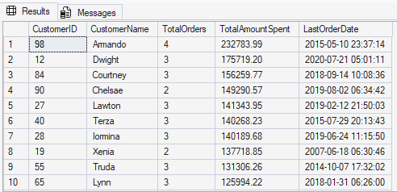

--Q10. Write a stored procedure sp_GetSupplierSales that takes a SupplierID as input and returns the total sales amount for all products supplied by that supplier.
CREATE OR ALTER PROCEDURE dbo.sp_GetSupplierSales
@SupplierID INT
AS
BEGIN
SET NOCOUNT ON;
SELECT s.SupplierID,s.Name AS SupplierName,
SUM(sod.TotalAmount) AS TotalSalesAmount
FROM dbo.Supplier s
JOIN dbo.PurchaseOrder po ON s.SupplierID=po.SupplierID
JOIN dbo.PurchaseOrderDetail pod ON po.OrderID=pod.OrderID
JOIN dbo.Product p ON pod.ProductID=p.ProductID
JOIN dbo.SalesOrderDetail sod ON p.ProductID=sod.ProductID
WHERE s.SupplierID=@SupplierID
GROUP BY s.SupplierID,s.Name;
END;
GO
EXEC dbo.sp_GetSupplierSales @SupplierID = 1;

